Looking to help Charlottesville create better routing for people in wheelchairs, or other pedestrians getting around town with mobility issues? Help us map sidewalks, curbs, crosswalks, and stairs around town to help facilitate creating open-source tools like http://accessmap.io/ !
TL/DR: Catch up with project lead Lena Nguyen on our Slack workspace and get involved!
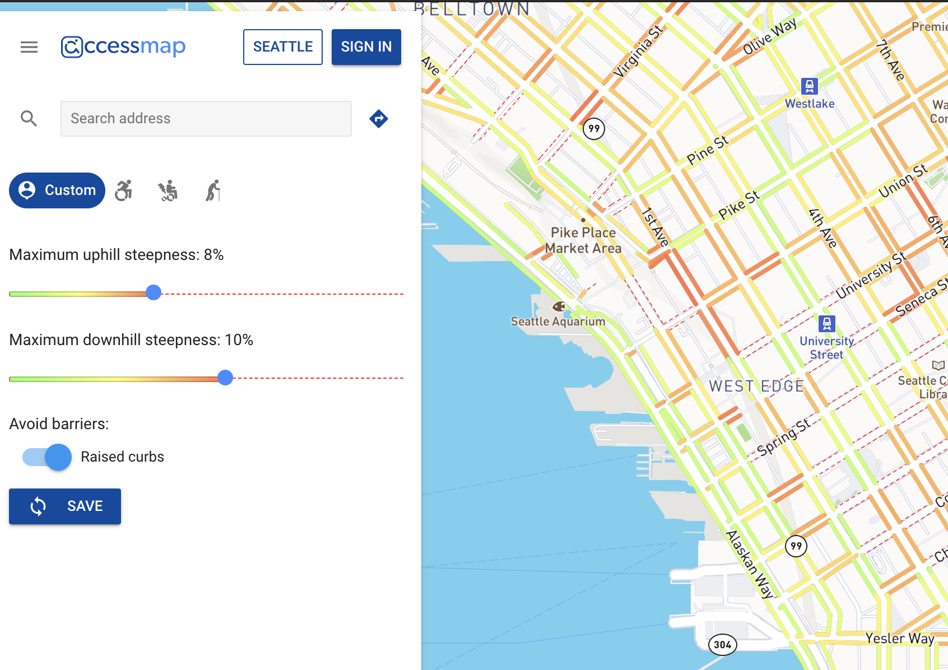
Map of sidewalks of Seattle with color based legend to indicate the steepness of the hills
How to participate:
- Create an OpenStreetMap account.
The account verification email may take a few minutes to send to your mailbox, so please be patient!

- Then head over to our task manager map by clicking https://tasks.openstreetmap.us/projects/239/ .
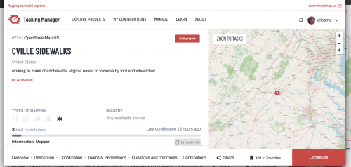
There you can find the Project Description, how many people have been contributing, and even when the last contribution was made!
- Select the Contribute button in the bottom right to start a mapping task. Then click to select one of the transparent blocks (the blue and green ones are either done or need to be validated!)
You can also click Zoom to Tasks located on the top left of the map on the right of the page to get an idea of what the area we are mapping looks like.
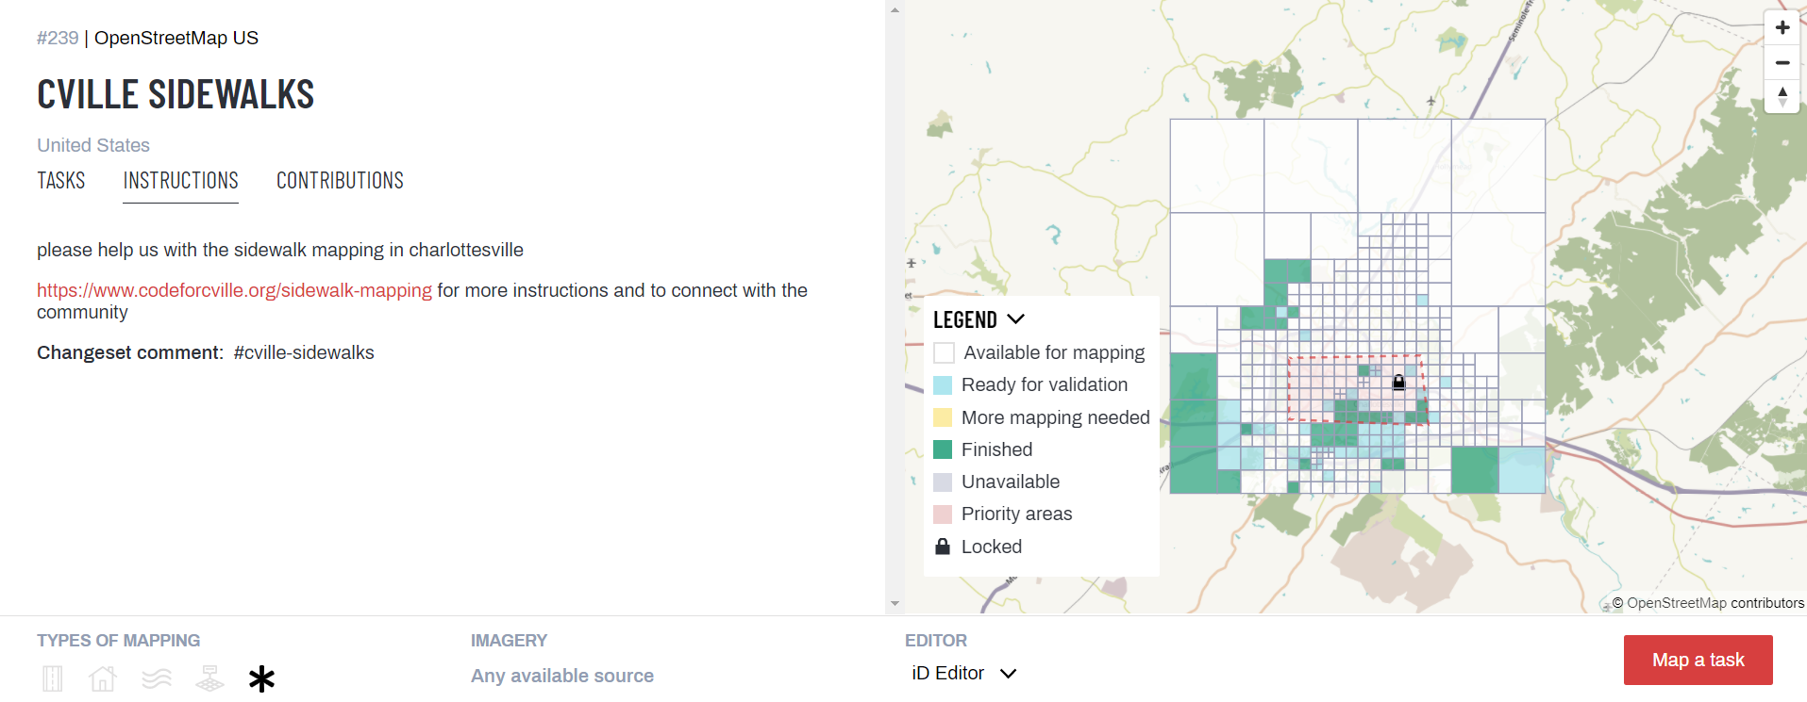
Note: The blocks in the red square are marked as priority areas due to higher foot traffic, but we welcome any and all contributions!
- From the Overview page, you can click to contribute to the map, and then either select a task yourself by selecting the transparent block and clicking Map selected task in the bottom right, or you can let the project assign you one randomly by clicking Map a task in the bottom right as well.
(We are going to be relying on aerial photography to help guide us, so please stick to areas you know well to begin with. We haven't got a validation process developed yet -- so to begin with just getting good data in the door is going to simplify our cleanup later :))

- After you've selected a region, under Background Settings, use the Layers tool to get the ESRI map.
It's a lot crisper but a bit older, so not every new sidewalk is present; that is why we stress you should aim to map areas you are quite familiar with! (Or you could take a quick drive through an area you would like to map!)
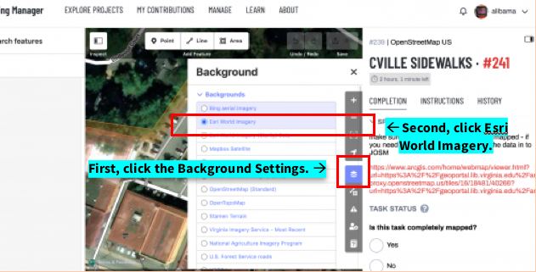

- Next, find an unmapped sidewalk and click on the Line tool to lay down a starting point for the sidewalk.
Always begin at the start of the sidewalk or the end of another sidewalk line. Also, try not to draw lines that are too long; you can click to draw intermediary points.
- To finish the line, map the endpoint then either click on the endpoint again, hit escape, or hit enter.
- After you do this, a Select feature type menu appears on the left. Here you can select Sidewalk. (You can also map Marked Crosswalks)

- You might see a yellow warning box in the menu. Any features you map should be anchored by another feature either already mapped or a feature you will create. You'll need to either connect the features (usually what's going on) or add a bridge or other 3d understanding to explain why the objects overlap in open street map.
Note: Creating sidewalks without clicking on every intersection is totally reasonable.
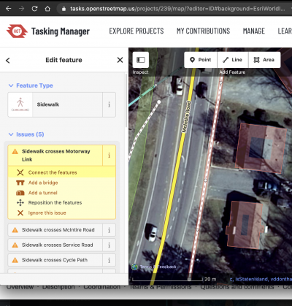

Note: There are Undo or Redo buttons if you would like to correct any mistakes!
- When you're done with your edits you can hit Save in the top right. Make sure the tag #cville-sidewalks is in the Changeset Comment box and click Upload.
This tag should already be a pre-set, but please double check. This helps keep track of our contributions and progress towards the project.
- 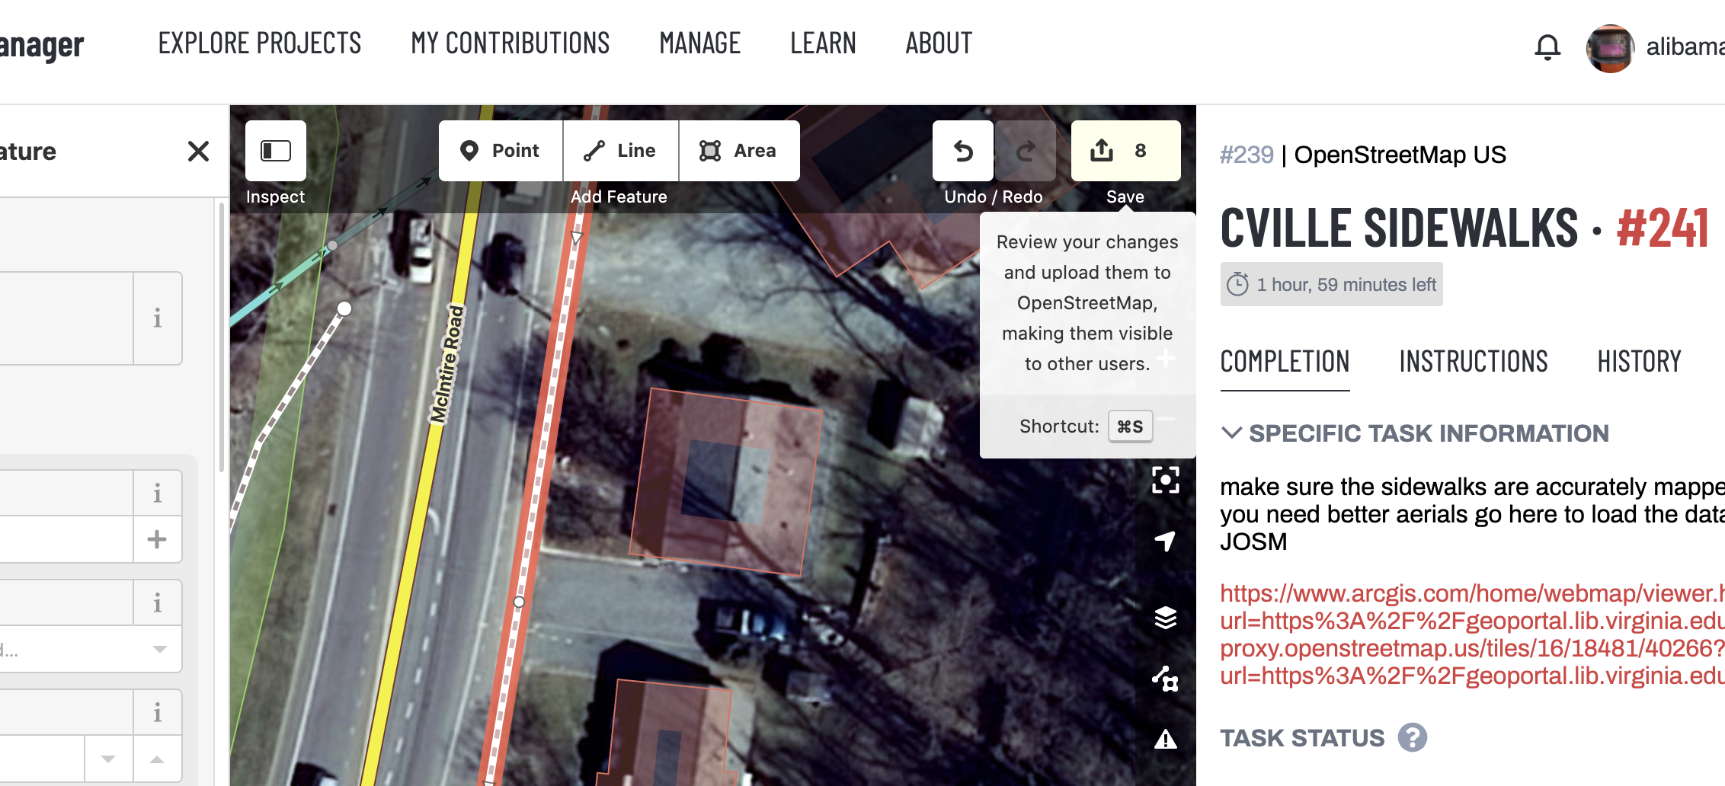

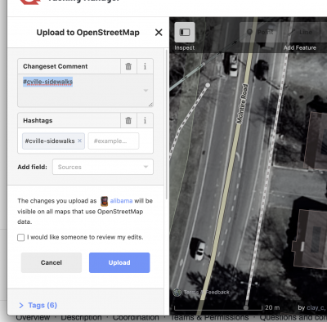
- When you’re done, you can update the Task Status on the right menu and click Submit Task.
-------------
*** Want to calculate how many KM of sidewalk you've mapped? Use this overpass OpenStreetMap tool to generate your scores!
http://overpass-turbo.eu/s/14Yl

